Chapter 16, Problem 83.

Refer to the RL circuit in Fig. 16.101. Find:

- the impulse response h(t) of the circuit
- the unit step response of the circuit.

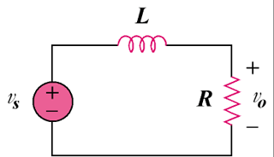

Figure 16.101
For Prob. 16.83.

